Joseph’s 2012 Christmas Wish List
Items prioritized top-to-bottom in each category

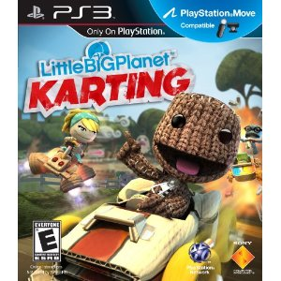
LittleBigPlanet Karting – PS3
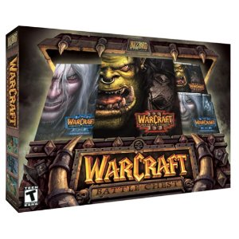
Warcraft III Battle Chest – PC
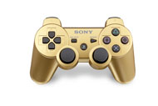
Metallic Gold Dualshock 3 Wireless Controller – GameStop Exclusive
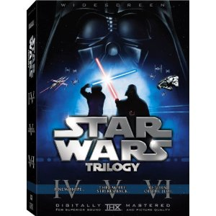
Star Wars Trilogy – DVD
Captain America: The First Avenger – DVD
John Carter – DVD
The Dark Knight Rises – DVD
Rise of the Planet of the Apes – DVD
The Amazing Spider-man – DVD
The Greatest Game Ever Played – DVD
The Chronicles of Narnia: Prince Caspian – DVD
Tron / Tron: Legacy – DVD

Fantastic Four: Rise of the Silver Surfer – The Power Cosmic Edition – DVD
The Tourist – DVD
Knight and Day – DVD
The Incredible Hulk – 3-Disc Special Edition – DVD
Star Wars: Episode I - The Phantom Menace – Widescreen Edition – DVD
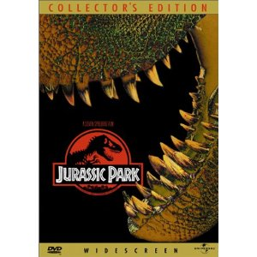
Jurassic Park – Widescreen Collector’s Edition – DVD

Amazon gift card
Flying Sumo gift card
PlayStation Network gift Card
Barnes & Noble gift card
Simply Sushi gift card

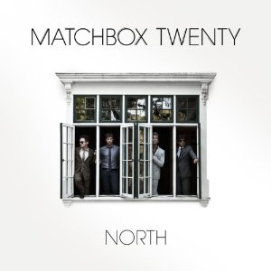
Matchbox Twenty – North

